Regulations:
A14

H.T No

Sreenidhi Institute of Science and Technology
(An Autonomous Institution)
Code No: 4B616 Date: 05-Feb-2020 (AN)

B.Tech III-Year II-Semester External Examination, Jan/Feb - 2020 (Supplementary)
Principle of Finite Element Method (ME)

Time: 3 Hours Max.Marks:70

Note: a) No additional answer sheets will be provided.
b) All sub-parts of a question must be answered at one place only, otherwise it will not be valued.
c) Missing data can be assumed suitably.

Part - A Max.Marks:20

Answer all QUESTIONS.

1. | How do you solve a problem using Rayleigh Ritz method? | [2M]
2. | Explain briefly about the formation of load vectors in beam problems. | [2M]
3. | What is the difference between ordinary and axisymmetric elements? Explain with example. | [2M]
4. | Draw neat sketches of tetrahedral and hexahedral elements. | [2M]
5. | Write the one-dimensional element equations for the steady state heat conduction through a plane wall and convection at the end surfaces with and without internal heat generation. | [2M]
6. | What is the importance of Eigen vectors and Eigen values in dynamic analysis? | [2M]
7. | What is meant by shape function? Explain its importance. | [2M]
8. | What are lumped mass matrix and consistent mass matrix? | [2M]
9. | Write the shape functions for a four noded quadrilateral element. | [2M]
10. | Write the strain displacement matrix for one dimensional bar element. | [2M]

Part – B Max.Marks:50
ANSWER ANY FIVE QUESTIONS. EACH QUESTION CARRIES 10 MARKS.

11. |  | Calculate the displacement at the free end of a 50cm long tapered bar of area of cross section 1000 mm² at its fixed end and 600 mm² at the free end, subjected to an axial tensile load of 1kN at the free end. Assume E = 200GPa. | [10M]
12. |  | For the cantilever beam subjected to the concentrated free-end load P and the uniformly distributed load w acting over the whole beam as shown in Figure determine the free-end displacements and the nodal forces.  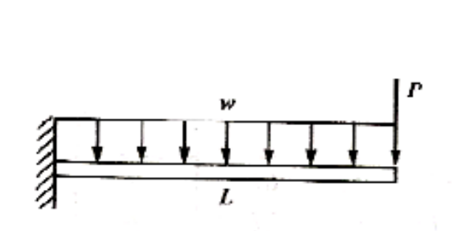 | [10M]
13. |  | The nodal coordinates and the nodal displacements of a triangular element, under a specific load condition are given below. X_{I} = 0, Y_{I} = 0, X_{J} = I mm, Y_{j} = 3 mm, X_{k} = 4 mm, Y _{k} = I mm U_{I} = I mm, V_{I} = 0.5 mm, U_{J} =-0.05 mm, V_{J} = 1.5 mm, U_{k} = 2 mm, V_{k} =-1 mm . If E = 2 x 10⁵ N/mm² and Poisson ratio = 0.3, find the stresses in the element. | [10M]
14. |  | 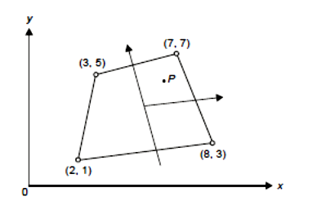  In the element shown in Fig., P is the point (6, 5). On this point the load components in x and y directions are 8 kN and 12 kN respectively. Determine its nodal equivalent forces. | [10M]
15. |  | A fin of length 12 cm has its cross section in the form a rectangle of width 5cm and thickness 2cm. Its base (left end) is at 200 ⁰C. The surrounding temperature is 25⁰C, the convective heat transfer coefficient is 2000 W/m²⁰C, and conductivity of the fin material is 300W/m⁰C. Determine the temperature distribution along the length of the fin by  (i) considering convection over the lateral surface only and  (ii) including convection over the right-end cross section along the convection over the lateral surface of the fin. | [10M]
16. |  | Derive element stiffness matrix and consistent mass matrix for a beam element subjected to transverse vibrations. | [10M]
17. | a) | Deduce the stress-strain relations in Cartesian coordinates for plane stress conditions. | [5M]
 | b) | Derive the strain displacement matrix for a two noded bar element. | [5M]
18. | a) | Derive thermal load vectors for one-dimensional heat flow due to internal heat generation and heat convection at the lateral surface. | [5M]
 | b) | Explain the procedure used to solve a problem using finite element analysis softwares. | [5M]

-- 00 -- 00 –

